RULES OF FAIR PLAY!
'Fair play' is usually understood to mean using only tactics that are in accord with the spirit of the sport. Most sports come with their own rules, conventions and opportunities for cheating.

1. RESPECT
Fair play requires unconditional respect for opponents, fellow players, referees and fans.
2. FRIENDSHIP
Rivalry on the field does not exclude friendship.

3. EQUALITY
Competing on equal terms is significant in sport. Otherwise performance cannot be measured properly.
4. SPORT WITHOUT DOPING
Someone who takes drugs cheats. Someone who cheats ruins the game. Someone who ruins the game cannot be played with.
5. TOLLERANCE
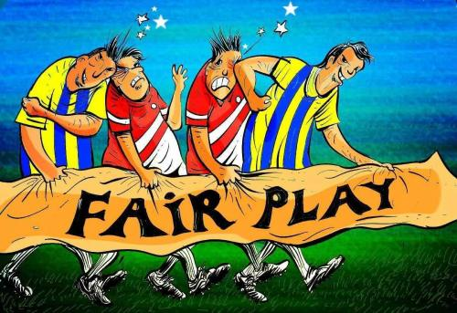
The willingness to accept behaviour or decisions you may not agree with develops your self-control and it could be the deciding factor when it comes to winning or losing.

6. TEAM SPIRIT
Individuals can be strong on their own but they are much stronger in a team. Victory achieved alone can be sweet but there is nothing sweeter than sharing that moment with your team.
7. SOLIDARITY
It is important to support each other and share feelings, aims and dreams. Mutual support brings mutual success on and off the field.
8. FAIR COMPETITION
To enjoy the fruits of success it is not enough to win. Victory must be scored by absolutely fair means and by honest play.
9. INTEGRITY
Being honest and having strong moral rules are essential to fair play. Practising sport within a sound ethical framework is vitally important if you aim to be a true champion.
10.JOY
Competition can be severe but you should always first look for joy when practising any sports. You should never forget about the play even in the heat of the fight.

