QUIZ - SPORT
Hello !!
Today we will check your knowledge about sport in a form of a quiz with 25 questions.
In a second you will start a short test which tells you how much do you know about sport.
When you will see the questions, think carefully about the answers. At the end of the quiz you will check how clever are you.
Sounds easy ?
Have fun and good luck !!
Let’s START !

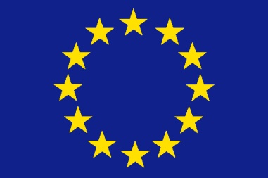 The World of Sports & Science. Two precious components in education of

European Citizen

- What sport is played at Wimbledon?
- Cricket b) Hockey c) Tennis
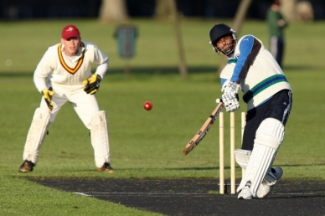
- In which city were the 2000 Summer Olympic Games held?
- Moscow b) Sydney c) Rio de Janeiro
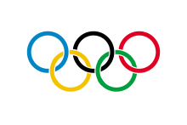
- What country does the soccer player Wayne Rooney come from?
- Ireland b) Canada c) England
- In which sport was Muhammad Ali the world champion?
- Boxing b) wrestling c) cycling
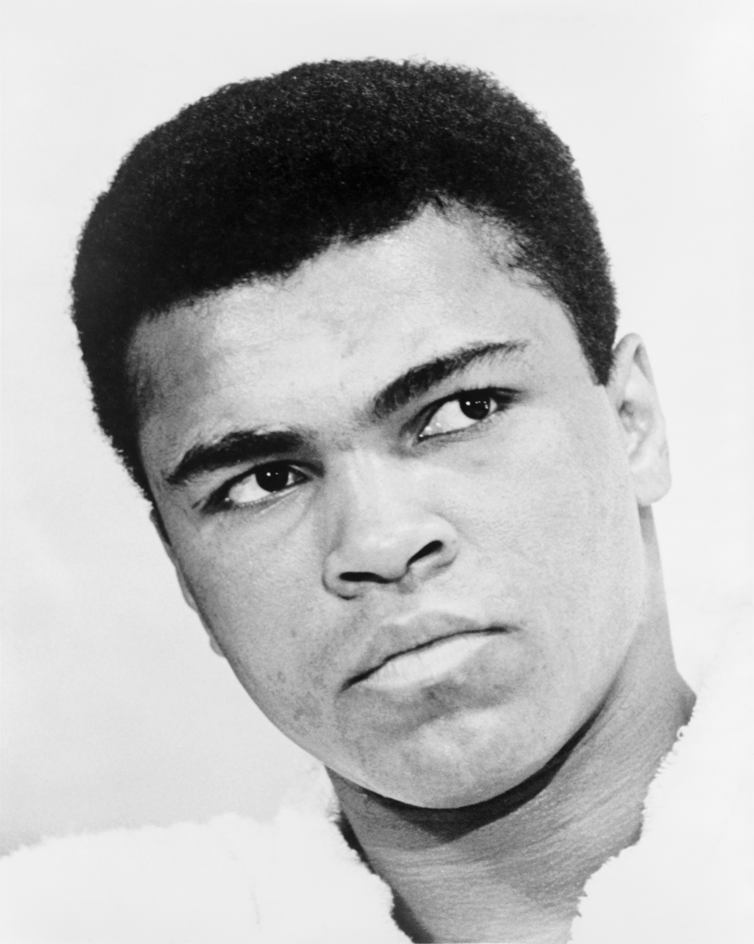
- How many bases are there on a baseball field?
- 4 b) 5 c) 6
- In what country were the 2010 Winter Olympic Games held?
- Italy b) Canada c) Germany
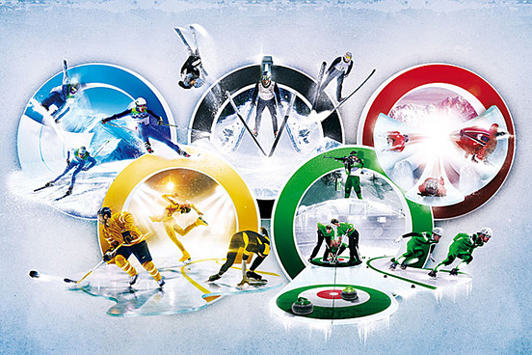
- A typical golf course features how many holes?
- 22 b) 20 c) 18
- What sport do the Los Angeles Lakers play?
- Basketball b) Baseball c) Hockey
- On which race course is the St Leger horse race run?
- Doncaster b) Corby c) Leicester
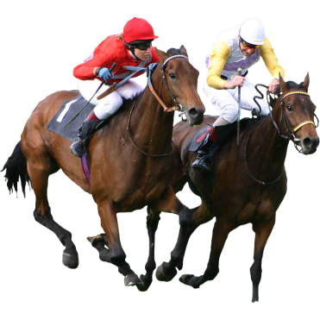
- Who competed in the 2008 Paralympics in Beijing, winning two swimming gold medals for Great Britain, despite being only 13?
- Sarah Jones b) Ellie Simmonds c) Ann Mc Nielh
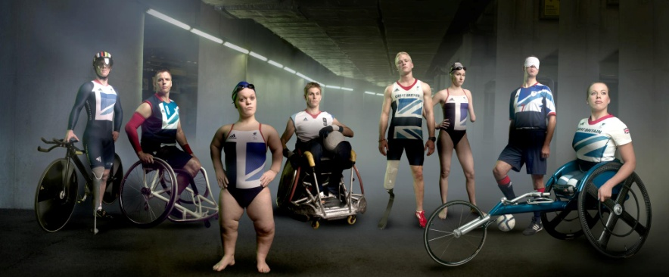

- The American basketball team 'The Bulls', represent which city?
- New York b) California c) Chicago
- How many players, including the goaltender, make up an ice hockey team?
- Six b) seven c) eight
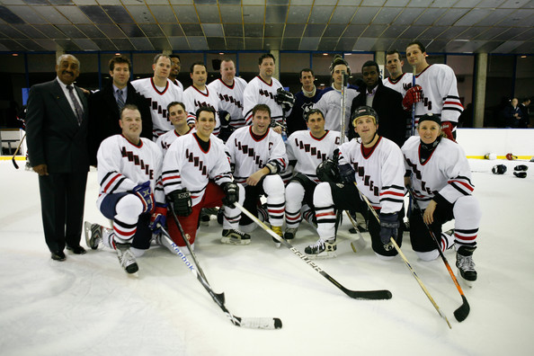
- Name the European club David Beckham ended his career with?
- Juventus Turin b) Paris Saint-Germain c) Manchester City
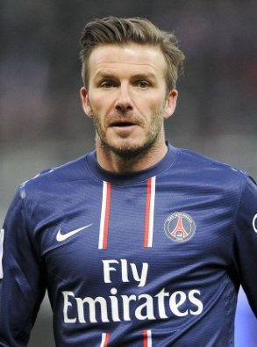
- Which sport featured in many of the Beach Boys earlier songs?
- swimming b) diving c) surfing
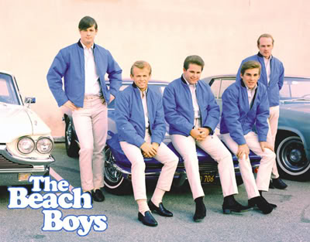
- The 100,000 capacity Empire Stadium, that opened in 1923, became better
known by what name?
- Wembley Stadium b) Old Trafford c) Anfield
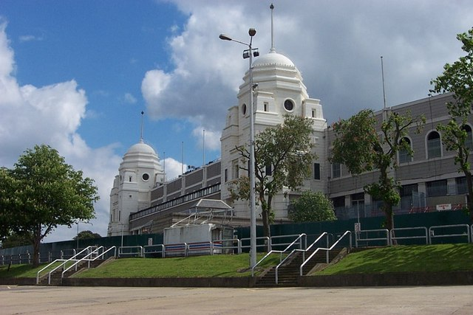
- What is the another name of ATHLETICS.
- sports b) gymnastics c) track and field
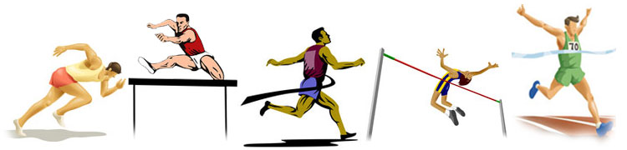
- How many lanes are there in a standard track?
- 6 to 9 b) 8 to 9 c) 10 to 12
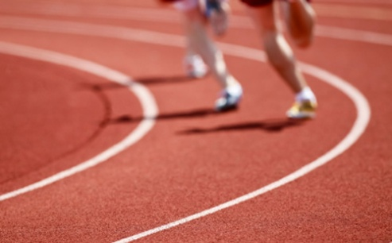
- Direction of running shall be
- Right hand side b) Left hand side c) none of these
- The Standard distance of Marathon Race is
- 26kms b) 42kms c) 42,195kms
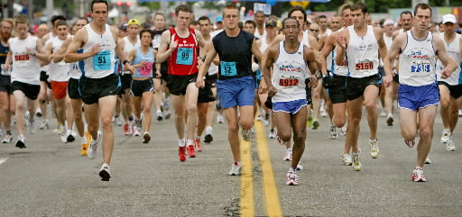
- The procedure of doping test is including the collection of
- Sugar sample b) blood sample c) urine sample
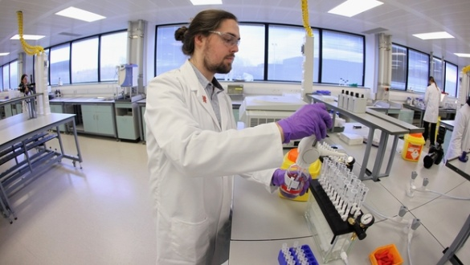
- When did the ancient Olympic game start?
- 776 B.C. b) 394 B.C. c) 676 B.C.
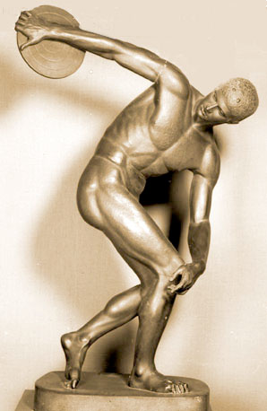
- How many rings are there in an Olympic Flag?
- 6 b) 5 c) 7
- Who is regarded to be the fastest runner in the world?
- Usain Bolt b) Tyson Gay c) Tirunesh Dibaba
- In which Italian city is located The San Siro Stadium?
- Milan b) Rome c) Bologna
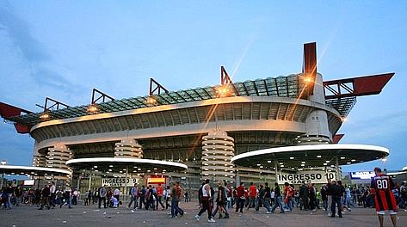
- Volleyball was invented in:
- 1835 b) 1895 c) 1875

Answer key :
1 c
2 b
3 c
4 a
5 a
6 b
7 c
8 a
9 a
10 b
11 c
12 a
13 b
14 c
15 a
16 c
17 a
18 b
19 c
20 c
21 a
22 b
23 a
24 a
25 b

Summary:

0 – 8 correct answers - You are definitely not into sports. Is your knowledge comparable to your physical condition ? If yes, you are in a big trouble!!

9 – 17 correct answers – Well done. You have some knowledge about sport but you are not a sporty type, are you? You know very well the basics, however you shouldn’t boast about it.

18 – 25 correct answers – Great !! You seem to be at least sport journalist, as you know lots of details on this field !! You are definitely a sporty type, who knows how to keep fit!! Good job!!

